PHP Demo Application

**Application Url:** [http://127.0.0.1:8000/](http://127.0.0.1:8000/register)default

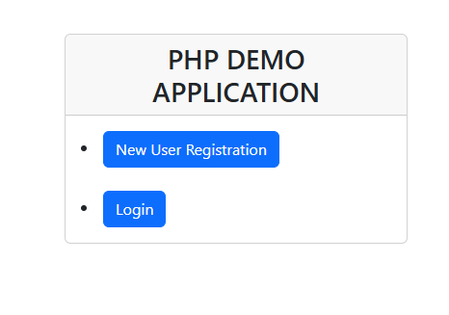

**New User Click Registration and fill the Form. Existing user Click Login button.**

**After Successful Registration Application redirect to login page.**

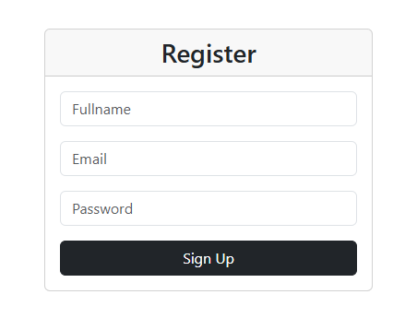

**After Successful User Registration. Application redirect to login page**

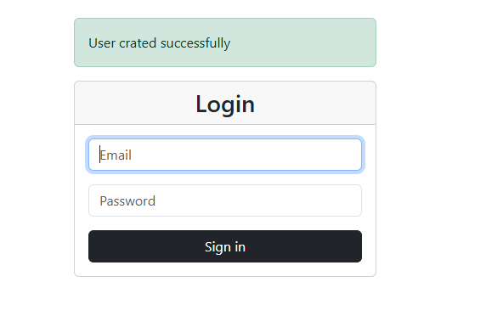

**After successful login. Application redirect to Home page**

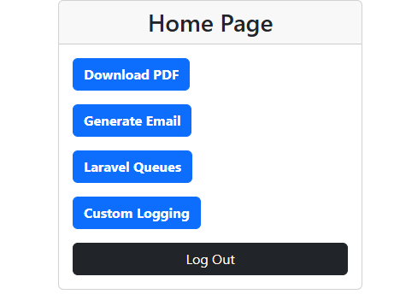

* **Download PDF** – Download employee data in the PDF file format.
* **Generate Email** –Employee data PDF file attached in the Email and send to configuration email id in the .env file.
* **Laravel Queues** – Queues will generate multiple Email based on Student records in the Data base students table.
* **Custom Logging** –if any error or bug error log will right in the custom log file. Below location. Herd\pdf_reports\storage\logs\custom.txt
* **Scheduler** to trigger report created – Execute the schedule email will send to configuration mail id id in the .env file.
  + cmd: php artisan schedule:work
* **Store Image file securely** – Route configuration middleware Authentication added so without user login file now able to access public url
  + File path: <http://127.0.0.1:8000/uploadedfile/PDF.jpg>
* **Unit testing** (controller) – pdftest.php file created for login user testing
* **dependency injection** code added DependencyController.php not able to execute throwing error.
* **Logout** – Page redirect to default page

**Note**: Application Created Model, View, and Controller

**Test PDF Email**

